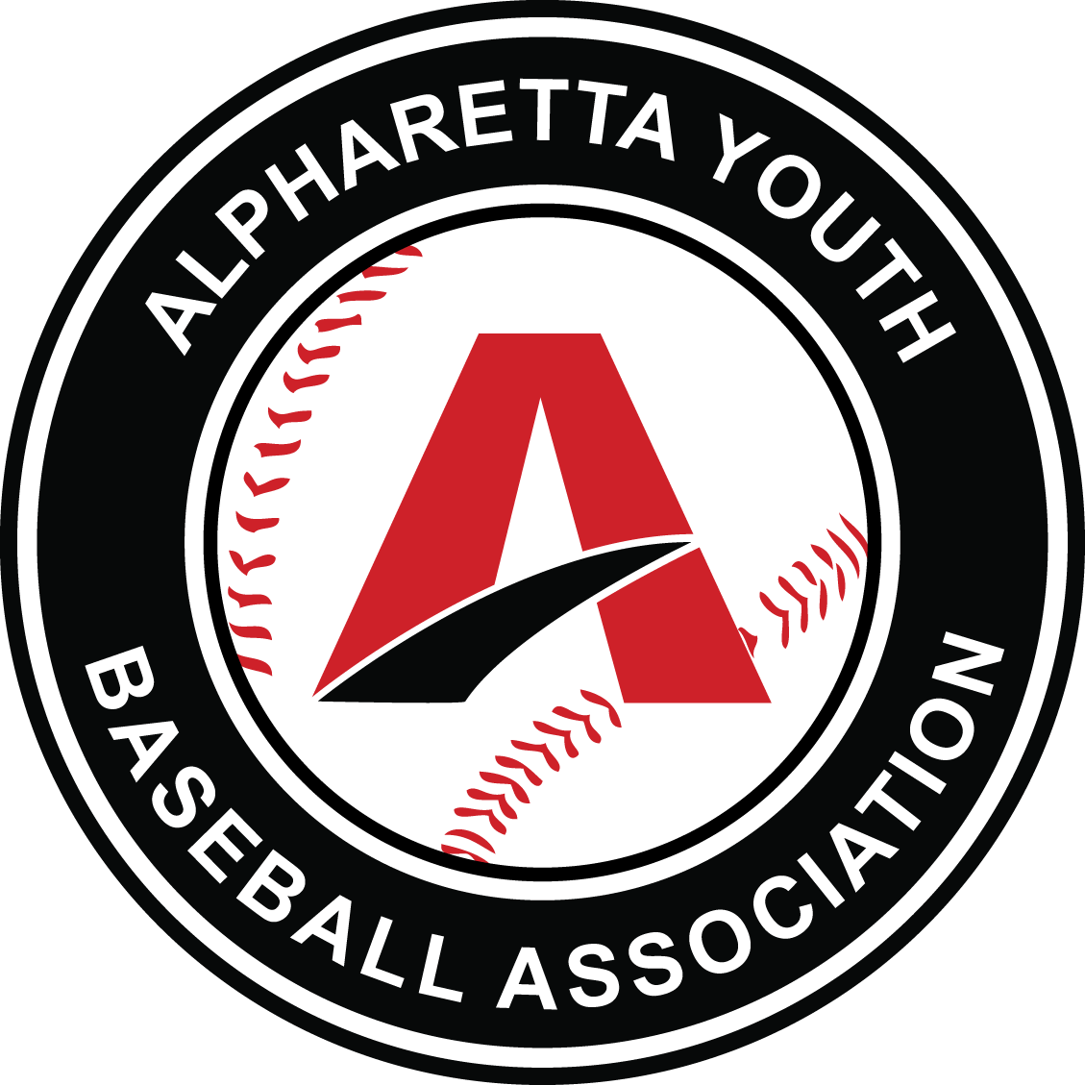  COACHES PLAYBOOK | ayba mission  To provide families with the best baseball experience possible. To accomplish this we focus on Skills development, Sportsmanship, Teamwork, and Fun!  SPRING 2021  Investing in our Volunteer Coaches to Achieve AYBA’s Mission

Thank you for volunteering to coach these kids in the game of Baseball for AYBA.
As a coach you have an incredible opportunity to make a difference in these kids’ lives from them learning something new about baseball, to sportsmanship, leadership, teamwork and friendship, something different for each kid.
The key to making this possible starts with a little bit of planning and preparation to make sure each Practice and Game is a great experience. It doesn’t matter if you are a winning or losing team, it’s about the competitive spirit and the time they have while at a baseball event.
Contents
COACHES CODE OF CONDUCT: 2
ROLE OF THE LEAGUE REP: 2
ROLE OF THE COACH: 2
RULES SHEET: 3
PRACTICES: 4
BATIING CAGES & PAVILION: 5
GAME TIME: 6
UMPIRES: 7
SCHEDULE: 7
WEATHER: 8
OPENING DAY: CANCELLED FOR 2021 DUE TO COVID 8
PICTURE DAY: 9
PARK CODES: 9
UNIFORMS: 9
TOURNAMENTS: 10
OUT OF PARK ALL-STARS: 10
IN PARK ALL-STARS: 10
END OF SEASON: 10
ADDITIONAL ITEMS: 10

COACHES CODE OF CONDUCT:
- AYBA has a simple mission: To provide families with the best baseball experience possible. To accomplish this we focus on skills development, sportsmanship, teamwork, and fun!
- Coaches must lead by example
- Do not hit or forcibly touch any child
- You do not need to deal with unruly kids or parents, notify the VP of Rec to communicate issues and they will be addressed accordingly.
- Set proper expectations for Parents Code of Conduct during games to be reasonable, professional, no use of foul or inappropriate language and parents are not allowed to confront another child at the park, on the field or in any situation for the purpose of correcting them, intimidating them or scolding them for something that occurred on the baseball field.
- Do not argue or fight with Umpires, call them names, use any profanatory our foul language.
- Do not find put yourself in any situation where you will end up on YouTube or any other social media platform that you will regret, don’t be that “YouTube Dad”.
- Lead positive, teamwork focused, baseball driven activities and conversation to ultimately drive FUN for the Kids!
- Do not discuss, force or require any religion or politics with the kids or parents during games and practices.

ROLE OF THE LEAGUE REP:
- The League Rep (LR) represents your age group/ division
- Liaison to the VP of Rec (ease communication)
- Issues, try to work it out with your LR first
- LR tracks standings, game scores and pitch counts (if applicable)
- LR helps communicate weather cancellations
- LR helps communicate and organize special events like picture day, opening day, button/magnet fund raising

ROLE OF THE COACH:
- Planning
- Manage team schedule
- Manage proper communication with parents and players
- Set proper expectations with parents
  - Getting their kids to practice and games on time
  - Game time behavior
    - Not yelling or bantering with the umpires
    - Not scolding or disciplining your child during a game
  - Discuss any team, player or personal issues with the coach directly, not with other parents
- Have a plan / lineup for every practice and game
- Encourage attendance for all practices, games and AYBA events
- Make sure proper equipment
- Teaching the kids baseball positions, offensive and defensive fundamental terminology,
- Player Etiquette understanding
  - Cheer for your team
  - Don’t yell when the pitcher is winding up
  - Don’t yell at players trying to make a play
  - Don’t yell, talk back or argue with the umpires
  - Don’t cut down or criticize players for a mistake, encourage positive reinforcement, “Get it next time”, “You got this”
  - Don’t throw your equipment
- Overall player and parent safety on the field and in the dugout
- Dugout management
  - Not playtime for the kids, act responsible and safe
  - Kids must stay in the dugout, not roaming the field area
  - Only the helper parent or coach allowed in dugout to keep kids organized and safe
  - No swinging or carrying bats around in dugout, bats to be hung on rack or in player baskets (4/5u/6u)
  - Have line up posted so kids know when they are up to bat
- Accident Form
  - Use for any injury or accident where possible medical attention was required or may be required
  - Complete the form same day or within 24 hours of the accident and submit to your VP of Rec and LR
  - Encouraged to verbally contact your LR or VP of Rec immediately following the Practice or Game
- Incident Communication
  - When there is an ejection of a player, coach or parent
  - When there is any altercation between any player / coach / parent / visitor / umpire
  - Contact your LR or VP of Rec immediately following the Practice or Game with the specific details
- Make sure the kids are having fun
- Your Job is to bring AYBA back repeat customers next season or year!

RULES SHEET:
- AYBA is affiliated with Dizzy Dean and uses the Dizzy Dean Rules as the primary rule to govern game situations.
- All recreation league play shall be governed by the current Official Major League Baseball Rules, modified by the current Dizzy Dean Official Rules Book, modified by the current Alpharetta Youth Baseball Association.
- Rules by age division can be found on the AYBA website; http://www.wpyba.org/documents/rules.html under the Documents tab > Rules page
- Highlight of some key rules;
  - Sliding at home
    - No head first slides
    - Head first back to a base from a lead off ok
    - Must avoid contact as much as possible
  - No suicide squeeze plays
  - Pitching Balks (ages 11/12u and above)
  - Infield Fly Rule (Age 11/12u and above)
  - Pitching counts and rest periods (provide Pitch Matrix)
  - Coaches plate meeting to start game
  - Base advancement
  - Bat Rules (Hand out bat rule sheet)
    - Talk to your parents about the Bat rules and make sure they are prepared
  - Number of players required for an official game
  - Player Substitution Rules
    - You can only use a sub if you are at less than 9 players
    - Sub players may be drafted from the same league
    - Substitute players can only play in outfield positions and must bat last in the lineup
    - No more than 2 players may be substituted
    - You need a minimum of 7 players to have an official game
    - Having 6 players or less is an automatic forfeit
    - If a player is ejected from a game due to poor sportsmanship/conduct, the team cannot substitute the ejected player with anyone other than a player from their own team.

PRACTICES:
- Spend 5 minutes planning your practices
- First Practice
  - Parents meeting
    - Get a Team Mom/Dad
    - Set expectations day one
      - Arrive to practices on time
      - Arrive at games __ time before start time
      - Confirm email addresses and phone numbers
      - We suggest using a team website to simplify communications (not required)
      - Make sure parents let you know ahead of time if their child cannot make a practice or game
      - Make sure the parents know how to get ahold of you the coaches
      - Ask all the parents if their child has an allergy or issue, they need to be aware of
      - Ensure parents know they cannot approach or scold another child for something that happened on the baseball field. They need to take it up with the coach and the other parents in a calm manner.
  - Get to know the kids
  - Do a couple drills to learn what each player can do
    - Stretching and Warm up
    - Throwing
    - Fielding grounders
    - Fielding pop fly’s
    - Throwing across infield
    - Throwing from outfield
    - Running
    - Hitting
  - Regroup a couple times and check the kids understanding
  - Have the kids repeat names of each player
  - End practice on a good note, fun running or throwing game
  - Build teamwork with the first practice, Cheer’s or something fun!
- Subsequent practices
  - Use practice plans
    - Fielding focused practice
    - Running & Hitting focused practice
    - Throwing, Outfield, Cut off focused practice
    - Mechanical and Situational focused practice
- Have consistency with parts of your practice
  - Warm ups, stretching and throwing – as a team
    - Throwing is one of the key areas of focus and not enough time is spent on this part, we expect them to already know how to throw.
  - Set rules early
    - Hustle
    - Listen when coach talks
    - No bat without a helmet on
    - Safety first
    - Be a good sport
  - Ending practice with a recap, check for understanding, assign homework
  - Have a team cheer or breakdown, kids of all ages love it
- Things to stay away from and avoid at practices
  - Kids standing around for long periods
  - One coach running practice with no helpers, ask parents to help
  - Long lines for drills, better to have two or three drills going on at once vs one drill
  - Unsafe situations, safety first
  - No plan, making it up on the fly
  - Each practice is the same
  - Doing game time practice each practice
  - Lack of consistency.

BATIING CAGES & PAVILION:
- Baseball Pavilion
  - Each hitting cage is numbered the same as the fields
  - If your normal practice time is rained out on Wills Park fields, use your batting cage for hitting and fielding drills
  - Only use your cage number that matches your scheduled field number
  - Webb Bridge cancelled events do not have cage time at Wills Park
  - Do not cut the zip ties to make longer cages, unsafe and people get hit
  - Must wear helmet in batting cage
  - Pitching lanes, be respectful of other teams
  - No Cricket, Football, Lacrosse allowed in the Pavilion, you can ask them to leave, they are trespassing, you can call the police and they will tend to them
  - No sunflower seeds or gum
  - Make sure your area is clean before you leave, pick up your trash!
  - Don’t just show up unscheduled and expect to have a cage, work with the scheduler If you’re looking for extra time in the Pavilion.
- Batting cages are located near or next to most fields
  - During your assigned practice, the batting cage is part of your scheduled space
  - Be safe in the batting cages, one kid at a time, the rest remain outside the cage
  - Webb Bridge has one cage per field, use assigned cage only!
  - Please do not remove L-Screens from batting cages or Pavilion
  - Must wear helmet in batting cage.

GAME TIME:
- Most coaches and teams arrive 45 minutes to 1 hour before game time
- Make sure their players are properly and legally equipped
- Coaches set the example for the players conduct yourself appropriately do not yell, argue, or make inappropriate remarks or gestures towards the umpires, coaches, parents, or players.
- Home team is responsible for the following at each game
  - Turning on Lights (if applicable)
  - Turning on Scoreboard
  - Providing someone to operate score board, no Kids please
  - Provide 2 New game balls at the umpire plate meeting
  - Keep the Official Score Book
- Home team gets the batting cage 60 minutes prior to game time for 30 minutes total
- Home team then gets field 30 minutes before game time for 30 minutes up to game start time so the kids can stay in the field
- Visitor team gets the field 60 minutes before game time for 30 minutes
- Visitor team gets the batting cage 30 minutes before game time for 30 minutes so they keep their helmets on and are ready to hit as soon as the game starts
- At the Home Plate Meeting with the two head coaches and the two umpires, make sure you agree and resolve the rules, specially anything in question, exchange line ups (Not necessary at 4/5u and 6u ages)
- Coaches on the field;
  - 4/5u Division –
    - Offense – 1st base coach, 3rd base coach, coach pitching, coach catching
    - Defense – 2 coaches allowed in the grass behind the infield allowed in Foul Ball Territory, NOT on the Field of Play, Head coach or Asst coach by dugout
  - 6u, 7u & 8u Division –
    - Offense – 1st base coach, 3rd base coach, coach pitching
    - Defense – 2 coaches allowed in the grass beyond the infield dirt in the foul ball territory, Head coach or Asst coach by dugout
  - 9/10u & 11/12u, 13/15u and 16/19u Division –
    - Offense – 1st base coach and 3rd base coach
    - Defense – one coach on a bucket outside the dugout (if you chose)
- Player rotations;
  - 4/5u – Mix them up each inning, make sure the 1st baseman can catch the ball and pays attention
  - 6u, 7u & 8u – each player is required to play infield and outfield by the end of the 4th inning
  - 9/10 Rec – Coaches should move kids around to find where they play the best and to teach them many areas of the game, it is not required but highly encouraged since this a young age and they are all still developing into baseball players
    - Later in the season, starting to assign kids to a position is reasonable as long as it is good for your players
  - 11/12 Rec – Coaches at the beginning of the season should move the kids around between infield and outfield, towards the end of the season you should see where their talents are and what positions best fit them
  - 13/15u and 16/19u – Coaches choice
- Kid Pitch divisions 9u and above – strongly encouraged to develop and rotate as many kids as pitchers as you can and NOT use the same two pitchers all season
- Between each inning, coaches or scorekeepers of both teams should confirm run count and pitch count (for kids pitch leagues only) to prevent any major discrepancy at the end of the game
- Any discrepancies in scoring of any type, the home team’s book is the official book
- At the end of each game, the coaches need to confer and agree on the score and pitch counts (if kid pitch league) and the Home team turns in the final results to the League Rep to keep track of standings
- Clean up your dugout before you leave, do not leave trash, bottles, equipment in dugouts
- Last game of the day, Home Team’s responsibility;
  - Turn off scoreboard lights
  - Turn off Field lights (if last game of the night, do not leave on for non AYBA or Georgia Bombers teams or father son practice. Lights are for AYBA TEAM practices and games ONLY.).

UMPIRES:
- Please do not argue with the umpires
- If you disagree with a call, ask for timeout, speak to the umpire that made the call in a calm manner
  - You can ask that umpire to confer with the other umpire to see if they saw it differently
- It goes without saying but please do not yell at the umpires, kick dirt, spit or touch the umpires, you can and may be ejected from the game
- The coach that attended the Home Plate pre-game meeting is the only coach that can officially question the umpires
- It is the coaches job to keep your parents in-line
  - If parents are yelling at the umpires or talking foul to the umpires the parents & head coach can be ejected from the game which means they will need to leave the park and they will not be able to attend the next game either
- If you have an issue with an umpire, not paying attention, does not know the rules, on their phone, then please get their name and let the VP of Rec or the Commissioner know the details of the situation and they will deal with the head umpire Director to resolve.

SCHEDULE:
- We try to make sure that the schedules are fair amongst all teams in each division
  - Same number of home teams and visitor team’s appearances
  - Same number of late games and late practices
  - Same number of practices at Webb Bridge
- You can trade practice times with other coaches in the same age division, work it out between the coaches and then let the League Rep know the final result
  - The League Rep will inform the Scheduler so the Master Schedule can be updated
- Games cannot be traded or moved for any reason
  - If you can’t make a game, find parents to help run the game while the head coach or assistant coach are absent
- Many Holidays and Special events are taken into consideration during the scheduling process but not all can always be accommodated, otherwise we would not have enough days to play the practices and games
- As many practices that can be scheduled before the first game is scheduled for all teams and then additional practices throughout the season are scheduled to provide as many events as possible in the season
- Any Rained-out practice at the beginning of the season will attempted to be rescheduled with space available
- Any Game rained out, will be made up during the season except for the last week of the season
  - Make up schedule will be provided as soon as it makes sense after the cancellation
- Updated Division Schedules will be provided accordingly throughout the season as needed
- PLEASE do not sneak on the fields to try to get additional practices in. Just because the space looks open on your schedule doesn’t mean it is open because there are other teams, divisions and groups that could be scheduled on the fields. If you feel your team needs an extra practice, then contact the scheduler, if the scheduler can schedule your team and the other teams a practice, then your new additional practice time details will be provided.

WEATHER:
- Visit http://www.wpyba.org/fieldstatus/index.html or click the Green Field Status Icon on the left side on any page of the AYBA website.
- If the “Feels Like” temperature falls below 40 degrees, events will be cancelled
- On days of inclement weather, the AYBA Field Status page will be updated by 4:00pm weekdays, 8:00am on Saturday and 10:00am on Sunday
- If the City determines that the fields are unplayable earlier in the day, then the website will be updated to provide as much notice as possible
- The Field Status page is only updated on Bad Weather days, watch the date on the page closely
- An email will be sent to the LR’s with the Field Status
  - LR’s will send email to the Coaches letting them know the Field Status
- PLEASE do not call asking what the field status will be before 4:00pm, if the Field Status page has not been updated it is because the City has not given us any information
- Lightning Warning System
  - There is no active system
  - If you see a lightning bolt, everyone should move to their cars and off the fields for a minimum of 20 minutes from the last seen Lightning strike.
  - For extended delays, coaches and umpires can agree to suspend the game and have it made up later.

OPENING DAY: CANCELLED FOR 2021 DUE TO COVID
- Champions Day Parade – Feb 29
  - A set of games from all divisions will be played first thing in the morning and will be scheduled to end at about the same time
  - When the teams are done, they will all meet on Field #8 immediately following their games to stage and be ready for the Parade
  - The second set of scheduled games after the parade will be required to attend the parade and will meet on Field #8 to prepare for the Parade
  - Parents will line up beside the sidewalk between the upper fields Flag pole and the Champions Wall and leading down to the Turf Field #4.
  - The teams will march from Field #8 to Field #4 and be announced as they pass the parents
  - The Parade will end on Field #4 where we will continue the Opening Day activities
  - We will have an Opening Prayer
  - Award ceremony
  - Celebrate last season’s Champions
  - City update on Wills and Webb Bridge Parks
  - First Pitch
  - Group Picture
  - Then second round of teams get 30 minutes to warm up and then start their games
  - There will be vendors and activities all day
  - Encourage parents and everyone to show, even if your game is later in the day or last in the day, your team is very welcome to attend and walk the Parade or just attend the ceremonies and activities.

PICTURE DAY:
- Picture day is on the schedule with the rain out date the following weekend, if Needed
- A schedule of your picture time will be provided a week prior to the date
- A catalog, Order form and CC form will be provided to send to parents to prepare before the day
- Button & Magnet Fundraising program
  - 100% of all proceeds go back to the Park to buy L-Screens, Batting Cage mats, Hitting T’s, Catchers gear and more.
  - It is an easy sell but we need the Coaches and Team Mom/Dad’s to make an attempt and explain it to the parents to try and get 100% participation
  - Even if a kid is not buying any single pictures they should still take an individual picture.

PARK CODES:
- Park codes for lights and coaches closet will be provided to you by the VP of Rec and intended only for coaches and assistant coaches. Do not provide to kids or parents for any reason. Do not leave lights on for people who may ask you, like Cricket, Softball or any other Baseball program. The Lights are ONLY for AYBA teams and Georgia Bomber Teams.
    - Codes will be provided by the Board

UNIFORMS:
- Uniforms are ordered based on history and averages for each age group
- Its best to line up the kids from shortest to tallest and then hand out the shirts from the smallest number to the smallest kid to the largest number to the biggest kid, write the number down by player, collect the shirts back if you determine you want to get names applied to the back of each shirt
- Shirt, Hat, Socks are provided for each player
- Coach can decide on pants color and suggest it to the parents
- If you have a very large player that does not fit into the provided Shirt or Hat, please let the Equipment Director know so a larger size can be ordered or provided
- Any left-over uniforms can be placed in the Coaches closet if you do not want to hang on them, please inform the equipment director if you are leaving any uniforms in the Coaches closet.

TOURNAMENTS:
- At the end of the Spring Season there are Double Elimination tournaments for all age groups except for the 4/5u division
- Tournaments are seeded and the League Rep will be tracking the rankings and update the coaches weekly throughout the season
- A Tournament Bracket will be provided by the scheduler to the League rep to use during the tournaments and update the teams daily
- Championship and Runner up Trophies are provided to the 1st and 2nd place teams in age groups 7u thru 19U.

OUT OF PARK ALL-STARS:
- Towards the end of the Spring Season, Communication will be provided to all coaches regarding the Out of Park (OOP) All-Star tryouts
- Tryouts are completed and Selected coaches draft their team
- Kids are notified and 1 practice a week is provided during the Spring season, then they pick up after the season is complete
- OOP All-Star teams will play several tournaments around the area through July when the season ends
- Only applies to age groups 6u, 7u, 8u, 9u, 10u, 11u and 12u (Cooperstown)
  - Number of teams by age group are dependent on quantity of players, coach’s availability and competitiveness.

IN PARK ALL-STARS:
- At the end of the regular Spring season, each player is provided with a ballot to vote for __ number of their fellow team mates that they believe should represent their team in the All-Star tournament
- In Park All-Stars are for the Age Divisions of 6u, 7u, 8u, 9/10u, and 11/12u
- Kids cannot vote for themselves
- Kids that made the In Park All-Star team are not eligible for the In Park All-Star teams
- Kids from the Even Seeded teams make up one team and kids from the Odd seeded teams make up the other team
- The In-Park All-Stars tournament is traditionally a Best of 3 Series, time and weather permitting.

END OF SEASON:
- At the end of the season, you will need to ensure the Equipment bag you were provided at the beginning of the season is returned to the Equipment Director.
  - Instructions will be provided by the Equipment Director prior to the end of the season
  - Make sure your equipment bag has your age group listed on it and your coaches name so your deposit check can be ripped up and destroyed
- End of the Season Participation Trophies / Medals are provided for each coach for their players
- Divisions that will receive Trophies include; 4/5u, 6u, 7u, 8u, 9/10u

ADDITIONAL ITEMS:
- At the end of the season an AYBA Parent Survey is sent out so AYBA can hear from the parents directly and find ways to constantly improve the program.
- Share Best Practices;
  - If you find baseball drills, games, processes or anything that you think other coaches or players can benefit from, please share it with the VP of Rec or the Player Development Board member so we can help others with your success.
- If you are unsure, do not hesitate to ask your League Rep, fellow coaches or an AYBA Board member. We need you to be successful and comfortable at coaching so please ask vs doing nothing and creating a possible bad experience for a child or parent.

